**FIRE DETECTION AND EXTINGUISHING SYSTEMS**

**A REPORT ON PROJECT BASED LEARNING**

**(SEMESTER -II)**

***Submitted by: -***

**Utkarsh Sanjay Magar (10463)**

**NAME OF CANDIDATES: -**

1. **SAHIL DATE (10455)**
2. **DIPTESH VARULE (10467)**
3. **ABHIJEET MAHAJAN (10461)**
4. **SUYASH MORE (10453)**
5. **NIDHI KOWTAL (10464)**
6. **NISHAD KULKARNI (10457)**

**FIRST YEAR ENGINEERING**



**Society for Computer Technology and Research’s**

**PUNE INSTITUTE OF COMPUTER TECHNOLOGY**

**DHANKAWADI, PUNE – 43**

**A.Y. 2019-20**

**- CERTIFICATE -**

This is to certify that the work incorporated in the report entitled **“FIRE DETECTION AND EXTINGUISHING SYSTEMS”** is carried out by Mr. MAGAR UTKARSH SANJAY (10463) , who is part a group of students with Project Id **1C42020** under the subject ***Project Based Learning*** during A.Y.2019-2020.

Such material has not been submitted to any other University/ Institute for any financial support. The literature related to the problem investigated has been appropriately cited and duly acknowledged wherever facilities and suggestions have been availed of.

**Date: 25/05/2020 Name & Sign of Project Guide**

**Place:** PUNE

Prof. A. H. CHAVAN

**Name & Sign of PBL Coordinator Name & Sign of Head of Department**

**Prof. N. P. Sapkal Prof. E. M. Reddy**

**ABSTRACT**

The project is based on making a fire extinguishing system based on DIY conventions. This project can be used in many ways and has many applications such as automated extinguishing system (which does not involve any human activity or does not harm any human).

The project is user friendly and can be manipulated by anyone. Conventionally used temperature sensor LM 35 get triggered by the raise in temperature. As the temperature reading bought from the temperature sensor are sent as an input to controller which initiates the water supply.

**ACKNOWLEDGEMENT**

We have taken efforts in this project. However, it would not have been possible without the kind support and help of many individuals. I would like to extend my sincere thanks to all of them.

I am highly indebted to **APARNA CHAVAN MADAM** for their guidance and constant supervision as well as for providing necessary information regarding the project & also for their support in completing the project.

I would like to express my gratitude towards my parents for their kind co-operation and encouragement which help me in completion of this project.

My thanks and appreciations also go to my colleague in developing the project and people who have willingly helped me out with their abilities.



Place :- Pune UTKARSH SANJAY MAGAR

**1** **Title of the Project** 1-10

**1 . 1** Introduction 1

**1 . 2** Relevance 2

**1 . 3** Objective 3

**1 . 4** Theoretical Principle 6

**1 . 5** Circuit/Block Diagram 7

**1 . 6** Specifications

**1.7** Working/Operation of project

**1.8** Conclusion

**1.9** Learning Outcomes

**1.10** References

**Abstract** i

**List of Acronyms** ii

**List of Symbols** iv

**List of Figures** vi

**List of Tables** vii

**TABLE OF CONTENTS**



**LIST OF FIGURES**

|  |  |  |
| --- | --- | --- |
| **Figure  No** | **Title** | **Page  No** |
|  | Circuit Diagram of the project |  |
|  | LM35 circuit diagram |  |

**INTRODUCTION:-**

Nowadays we encounter with the fires generated at various places such as home, offices, schools, etc. Such fires ,which may occur due to short circuits, causes damage to various appliances as well as leads to damage to the property.

So, it is essential to develop automated systems which would help us to detect the fires and help us to extinguish that fire. Hence our project is based on “FIRE DETECTION AND EXTINGUISHING SYSTEMS”. We have designed an electronic circuit including an Arduino UNO .

The circuit consists of the temperature sensor LM 35 which detects the fire generated .We have an program written in Arduino UNO which cuts the electrical supply of the home once the fire is encountered and activates a water pump to extinguish fire.

**RELEVANCE: -**

The **Importance of Fire Extinguishers**…

Stay safe by having a **fire extinguisher** handy...

**Fire extinguishers** are extremely important as they are the most commonly used for of **fire** protection. In many cases they are a first line of defense and often contain or extinguish a **fire**, preventing costly damage.

This system consists of a LM35 temperature sensor, relay circuits, LCD, the microcontroller and water pump system. So basically, this whole system is related to the whole electronics based project which is useful in daily life aspects.

**OBJECTIVE: -**

The main objective of our project is to detect fire or electric mishap at our homes using temperature sensors, and then extinguish the fire using water. In the meantime, the module starts spreading water and over fire lit area.

Thus, some the basic objectives include :-

● To implement the working principle and operation of an automatic fire alarm.

● To study about different types of temperature sensors like LM35 temperature sensor.

● To study about other minor components like transistors and LEDs.

● To study about Arduino UNO R3 working in detail.

**THEORETICAL PRINCIPLE: -**

**WORKING PRINCIPLE OF the fire alarm**

Putting together the components to be used in the fire alarm. The working principle goes as follows :-

**At room temperature**:

The LM35 temperature sensor does not show any stimulus when the temperature of the room is 20-45 degree Celsius.

**Linear increase in the temperature of the room:**

Unlike the thermistor, precision IC sensors linearity is very good accuracy at 0.5°C and has an ample range of temperatures. The o/p of this is comparative to the Celsius temperature. The temperature operating range of this IC ranges from **-55° to +150°C**. It draws only above 50 µA from its supply and the main features are self-heating and < 0.1 degrees centigrade in the air. This IC operating voltage ranges from 4volts to 30volts, and the o/p is 10mv°C.

The sensor thus shows stimulus to the increasing temperature and facilitates the working of the Arduino UNO which thereby stimulates the activation of a dc motor. From here the extinguishing mechanism takes place and the water from the supply system will be used to extinguish the fire.

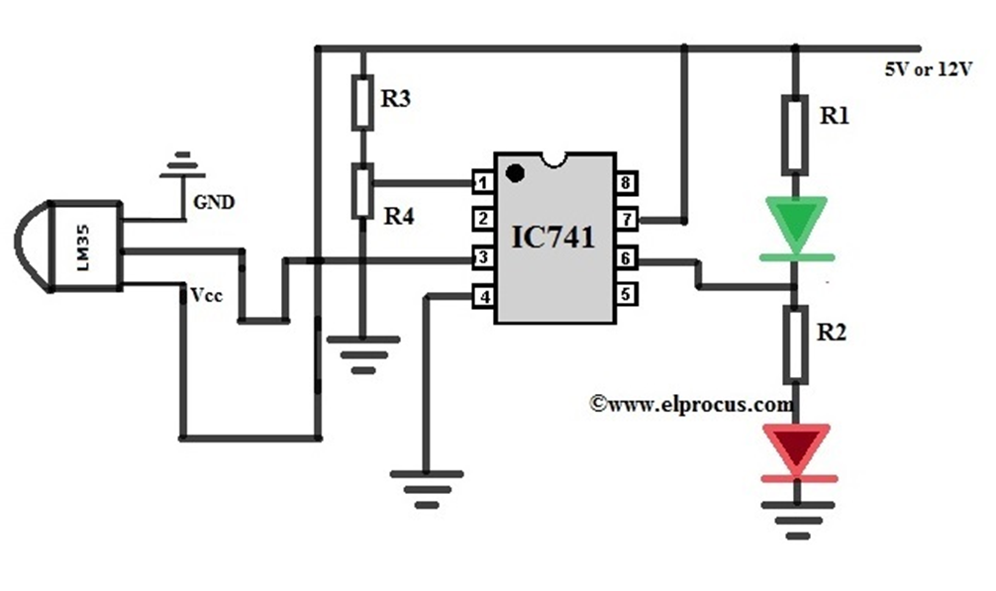

The circuit representation of the temperature sensor is shown below. The following circuit can be built with an LM35 temperature sensor. The main function of this sensor is to sense the exact centigrade temperature.

Unlike the thermistor, precision IC sensors linearity is very good accuracy at 0.5°C and has an ample range of temperatures. The o/p of this is comparative to the Celsius temperature. The temperature operating range of this IC ranges from -55° to +150°C. It draws only above 50 µA from its supply and the main features are self-heating and < 0.1 degrees centigrade in the air. This IC operating voltage ranges from 4volts to 30volts, and the o/p is 10mv°C.

**CIRCUIT/ BLOCK DIAGRAM: -**

**Full Circuit Diagram:-**

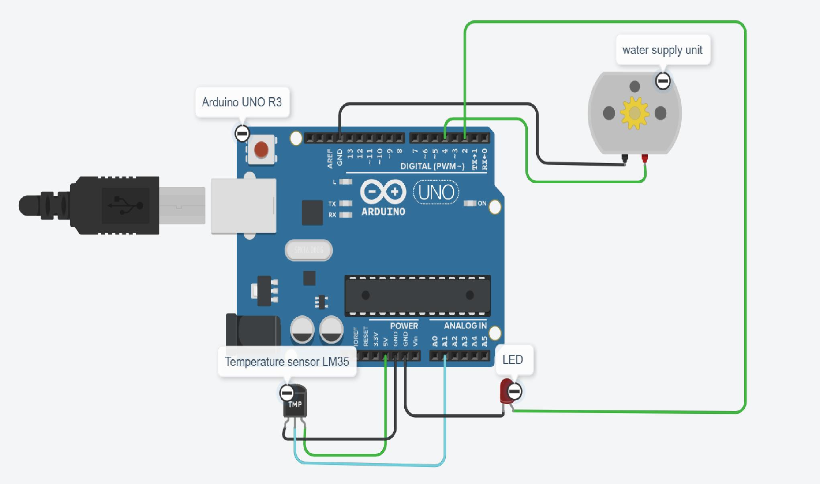

**LM35 Temperature Sensor:-**

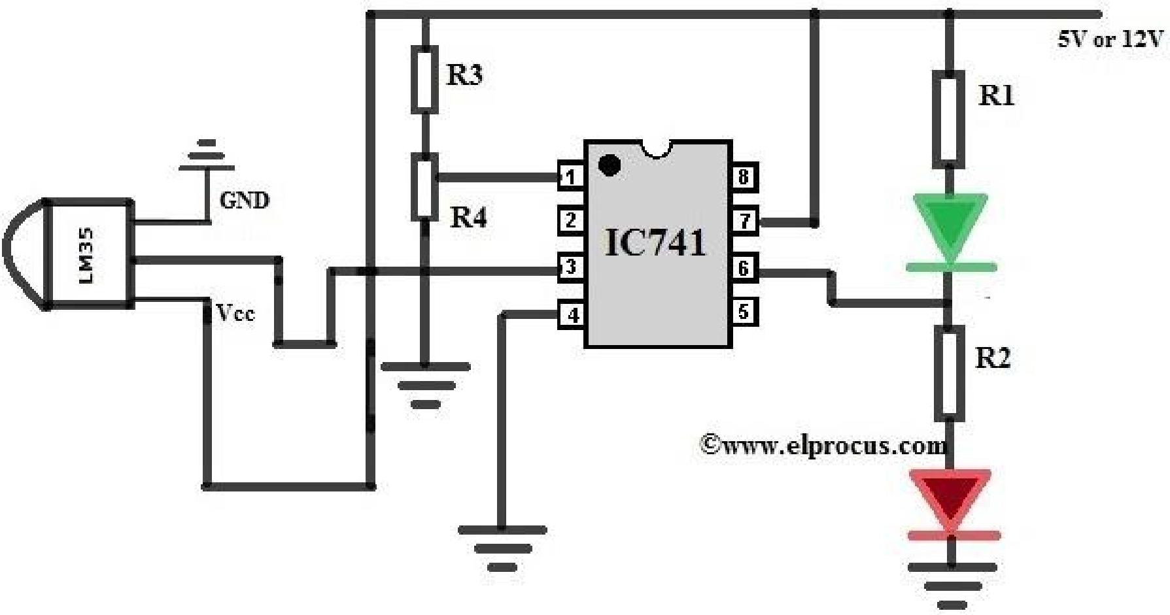

**Temperature Sensor Circuit (LM35) circuit explanation:-**

Here, the voltage of this circuit can be set by using a potentiometer at the pin-2 of IC. The circuit can be designed to activate or deactivate a device at a specific edge temperature. The temperature can be indicated by using two LEDs namely green LED.

The secondary IC o/p enlarges in proportion to the temperature by 10 mV/°. This changing voltage is supply to an IC 741 OP Amplifier. These are extensively used integrated circuits. It has two terminals namely inverting (input (-)), and non-inverting (output (+)). This circuit uses a 741 op-amp as a non-inverting amplifier which means the input pin is pin-3, and the o/p pin is inverted. This circuit increases the variation between its input terminals.

**Arduino Uno Technical Specifications**

|  |  |
| --- | --- |
| 1] Microcontroller | [ATmega328P](https://components101.com/microcontrollers/atmega328p-pinout-features-datasheet) – 8 bit AVR family microcontroller |
|  |  |
| 2] Operating Voltage | 5V |
|  |  |
| 3] Recommended Input Voltage | 7-12V |
|  |  |
| 4 ] Input Voltage Limits | 6-20V |
|  |  |
| 5] Analog Input Pins | 6 (A0 – A5) |
|  |  |
| 6] Digital I/O Pins | 14 (Out of which 6 provide PWM output) |
|  |  |
| 7] DC Current on I/O Pins | 40 mA |
|  |  |
| 8] DC Current on 3.3V Pin | 50 mA |
|  |  |
| 9] Flash Memory | 32 KB (0.5 KB is used for Bootloader) |
|  |  |
| 10] SRAM | 2 KB |
|  |  |
| 11] EEPROM | 1 KB |
|  |  |
| 12] Frequency (Clock Speed) | 16 MHz |

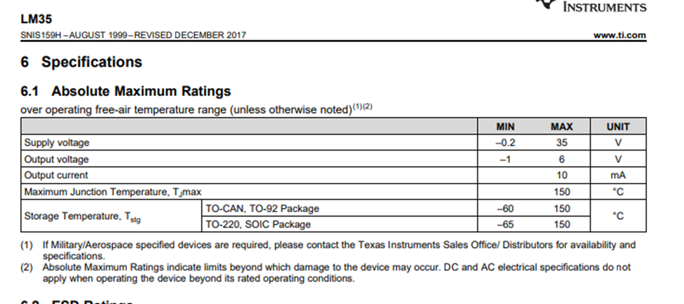

**WORKING/OPERATION OF PROJECT: -**

The main functioning of the project is based on the controller called as ARDUINO UNO R3. It is used in many IOT projects. So, the brain behind this is the controller. The peripherals attached to the controller are LED, Water supply unit and LM35 temperature sensor. The temperature sensing range of the sensor is -55° to +150°C. The temperature is taken as input from the sensor to the controller. The value for a normal room temperature is been set in the controller. As the temperature taken input from the sensor exceeds the given value of the normal room temperature the water supply system is started, and the LED goes on due to high temperature.

Again, when the temperature is lowered due to the water supply to the fire lit area, the temperature falls below the room temperature the water supply and the LED goes off indicating the temperature is below the room temperature.

The code used for the controller is as follows: -

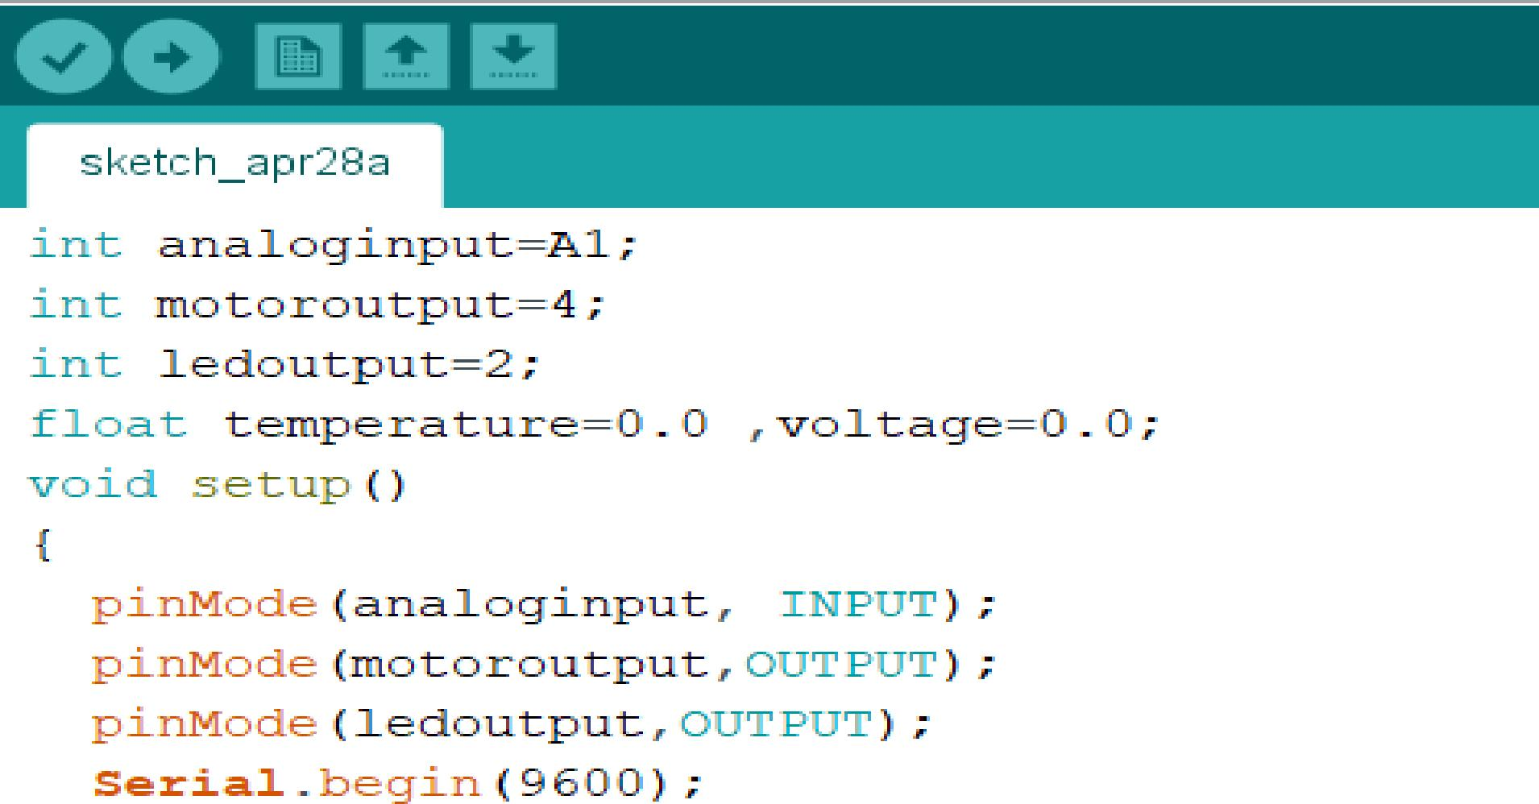

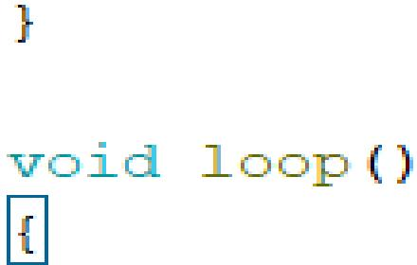

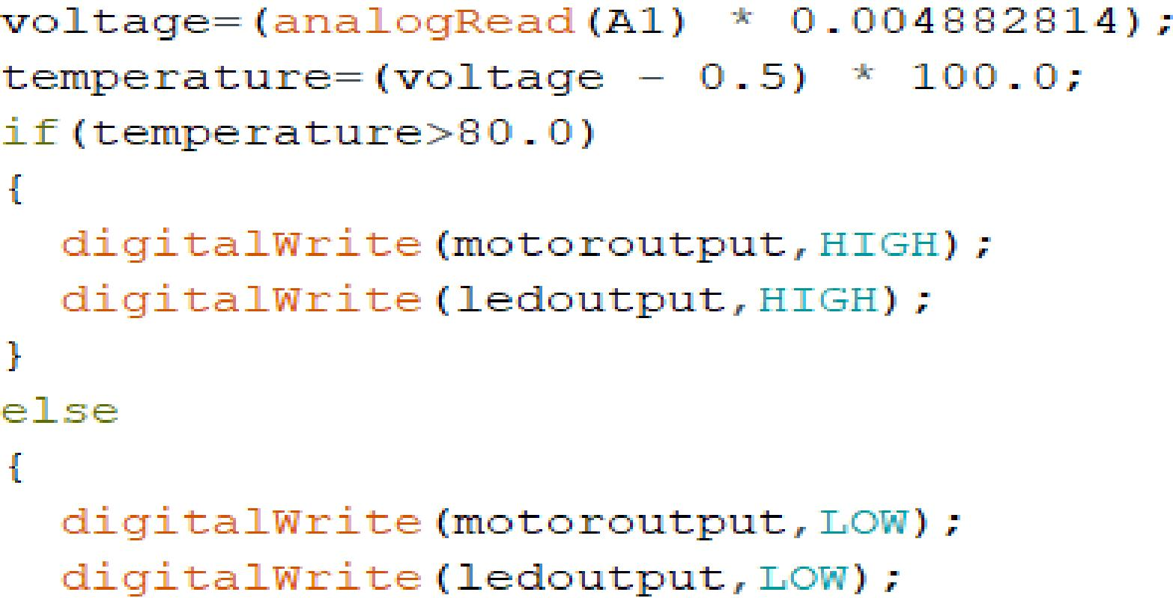



**CONCLUSION :-**

The project **FIRE DETECTION & EXTINGUSHING SYSTEM** is basically a project which is used in household and industrial area where the chances of getting fire is high.

This Module automatically detects the fire and start the water motor to extinguish it. This module automatically detects the type of fire like fire due to electricity and other sources of fire.

**REFERENCES**

1. TINKERCAD - <https://www.tinkercad.com/>
2. ARDUINO IDE
3. LM35 DATA SHEET - http://www.ti.com/lit/ds/symlink/lm35